**Module 5**

**1. Permutation Of Strings**

#include <stdio.h>

#include <stdlib.h>

#include <string.h>

int next_permutation(int n, char **s)

{

int i,j;

int k = -1;

for ( i = 0; i < n-1; i++) {

if (strcmp(s[i], s[i+1]) < 0)

k = i;

} if ( k== -1) return 0;

int l = -1;

for ( i = k+1; i < n; i++) {

if (strcmp(s[k], s[i]) < 0)

l = i;

}

char *tmp = s[k];

s[k] = s[l];

s[l] = tmp;

i = k+1, j = n-1;

while (i < j) {

tmp = s[i];

s[i++] = s[j];

s[j--] = tmp;

}

return 1;

}

int main()

{

char **s;

int n,i;

scanf("%d", &n);

s = calloc(n, sizeof(char*));

for ( i = 0; i < n; i++)

{

s[i] = calloc(11, sizeof(char));

scanf("%s", s[i]);

}

do

{

for ( i = 0; i < n; i++)

printf("%s%c", s[i], i == n - 1 ? '\n' : ' ');

} while (next_permutation(n, s));

for ( i = 0; i < n; i++)

free(s[i]);

free(s);

return 0;

}

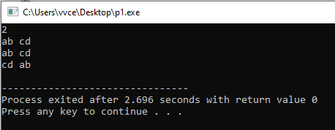

**2. 2D Array**

#include <assert.h>

#include <ctype.h>

#include <limits.h>

#include <math.h>

#include <stdbool.h>

#include <stddef.h>

#include <stdint.h>

#include <stdio.h>

#include <stdlib.h>

#include <string.h>

char* readline();

char* ltrim(char*);

char* rtrim(char*);

char** split_string(char*);

int parse_int(char*);

int main()

{

int i,j,k;

int arr[6][6],temp=-9999,a,b;

for(i=0;i<6;i++)

for(j=0;j<6;j++)

scanf("%d",&arr[i][j]);

for(i=0;i<=3;i++)

for(j=0;j<=3;j++)

{

a = arr[i][j]+arr[i][j+1]+arr[i][j+2]+arr[i+1][j+1]+arr[i+2][j]+arr[i+2][j+1]+arr[i+2][j+2];

if(temp < a)

temp = a ;

}

printf("%d",temp);

return 0;

}

char* readline() {

size_t alloc_length = 1024;

size_t data_length = 0;

char* data = malloc(alloc_length);

while (true) {

char* cursor = data + data_length;

char* line = fgets(cursor, alloc_length -data_length, stdin);

if (!line) {

break;

}

data_length += strlen(cursor);

if (data_length < alloc_length -1 || data[data_length -1] == '\n') {

break;

}

alloc_length <<= 1;

data = realloc(data, alloc_length);

if (!data) {

data = '\0';

break;

}

} if (

data[data_length -

1] == '\n') { data[data_length -1] = '\0';

data = realloc(data, data_length);

if (!data) {

data = '\0';

}

} else {

data = realloc(data, data_length + 1);

if (!data) {

data = '\0';

} else {

data[data_length] = '\0';

}

} return data;

}

char* ltrim(char* str) {

if (!str) {

return '\0';

} if (!*str) {

return str;

}

while (*str != '\0' && isspace(*str)) {

str++;

} return str;

}

char* rtrim(char* str) {

if (!str) {

return '\0';

} if (!*str) {

return str;

}

char* end = str + strlen(str) -1;

while (end >= str && isspace(*end)) {

end--;

}

*(end + 1) = '\0';

return str;

}

char** split_string(char* str) {

char** splits = NULL;

char* token = strtok(str, " ");

int spaces = 0;

while (token) {

splits = realloc(splits, sizeof(char*) * ++spaces);

if (!splits) {

return splits;

}

splits[spaces -1] = token;

token = strtok(NULL, " ");

} return splits;

}

int parse_int(char* str) {

char* endptr;

int value = strtol(str, &endptr, 10);

if (endptr == str || *endptr != '\0') {

exit(EXIT_FAILURE);

} return value;

}

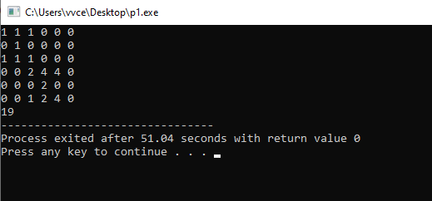

**3. Dynamic array**

#include <stdio.h>

#include <stdlib.h>

int main() {

int n, q,i=0;

scanf("%d %d", &n, &q);

// Create an array of dynamic arrays for the shelves

int** shelves = (int**)malloc(n * sizeof(int*));

int* sizes = (int*)malloc(n * sizeof(int)); // To keep track of the number of books in each shelf

int last_ans = 0;

// Initialize sizes

for ( i = 0; i < n; i++) {

sizes[i] = 0;

shelves[i] = NULL; // Initialize each shelf to NULL

}

// Process each query

for ( i = 0; i < q; i++) {

int query_type, x, y;

scanf("%d %d %d", &query_type, &x, &y);

// Calculate the index for the shelf

int idx = (x ^ last_ans) % n;

if (query_type == 1) {

// Add a book with y pages to shelf idx

shelves[idx] = (int*)realloc(shelves[idx], (sizes[idx] + 1) * sizeof(int));

shelves[idx][sizes[idx]] = y; // Add the number of pages

sizes[idx]++; // Increment the count of books on shelf idx

} else if (query_type == 2) {

// Retrieve the number of pages in the y-th book on shelf idx

last_ans = shelves[idx][y % sizes[idx]];

printf("%d\n", last_ans);

} else if (query_type == 3) {

// Print the total number of books on shelf idx

printf("%d\n", sizes[idx]);

}

}

// Free allocated memory

for ( i = 0; i < n; i++) {

free(shelves[i]); // Free each shelf

} free(shelves); // Free the shelves array

free(sizes); // Free the sizes array

return 0;

}

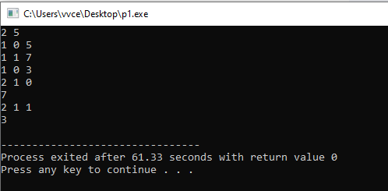

**4. Printing Tokens**

#include <stdio.h>

#include <string.h>

#include <math.h>

#include <stdlib.h>

int main() {

char *s;

int i;

s = malloc(1024 * sizeof(char));

scanf(“%[^\n]”, s);

s = realloc(s, strlen(s) + 1);

for(i=0;i<strlen(s);i++){

if(*(s+i)==’ ‘)

printf(“\n”);

else

printf(“%c”,*(s+i));

}

free(s);

return 0;

}

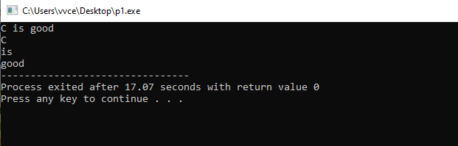

**5. Index of first occurrence of a string (Leetcode)**

#include <stdio.h>

#include <string.h>

int main() {

char haystack[100];

char needle[100];

scanf("%s", haystack);

scanf("%s", needle);

int result = strStr(haystack, needle);

printf("%d\n", result);

return 0;

}

int strStr(char* haystack, char* needle) {

int hsize = strlen(haystack);

int nsize = strlen(needle);

int res =-1;

int i = 0, j= 0;

while (haystack[i]!='\0' && needle[j]!='\0' ) {

if (haystack[i] == needle[j]) {

i++; j++;

}

else {

i++; j = 0;

}} if (

j

== nsize)

res =(i- nsize);

else

res=-1;

return res;

}

